Project Report
1. INTRODUCTION
1.1 Project Overview
The project, Automated School IT Ticket Classification and Notification System, is developed using ServiceNow to automate the classification of IT support tickets. The system identifies the issue from the ticket description and automatically assigns the appropriate Category and Subcategory. It also sends an email notification to the Caller.
1.2 Purpose
The purpose of the system is to reduce manual ticket classification, improve data consistency, speed up IT support processes, and provide automated notifications to users.

2. IDEATION PHASE
2.1 Problem Statement
School IT Helpdesk staff receive multiple requests related to Wi-Fi, projectors, passwords, and computer performance. Manually reviewing and categorizing every ticket is time-consuming and may lead to errors. An automated system is required to classify tickets and notify users efficiently.
2.2 Empathy Map Canvas
Section | Content
Think & Feel | Concerned about workload and incorrect ticket classification.
Hear | Frequent complaints about IT issues from students and teachers.
See | Large number of IT support requests requiring manual processing.
Say & Do | Review tickets, identify issues, assign categories, and respond to users.
Pain | Manual classification, repetitive work, delays, and possible errors.
Gain | Faster classification, reduced workload, consistent ticket handling, and timely notifications.

2.3 Brainstorming
The proposed ideas included:
- Automatic ticket classification.
- Category and Subcategory dependency.
- Flow Designer automation.
- Automated email notification.
- Structured ticket data storage.
- Easy maintenance and future scalability.
3. REQUIREMENT ANALYSIS
3.1 Customer Journey Map
Create IT Ticket
↓
Enter Issue Description
↓
Submit Ticket
↓
Automatic Classification
↓
Category & Subcategory Assigned
↓
Email Notification
↓
IT Helpdesk Processes Ticket
3.2 Solution Requirement
The system must:
- Automatically classify IT tickets.
- Assign Category and Subcategory.
- Support dependent Category–Subcategory choices.
- Send an automated email to the Caller.
- Store ticket information in a structured format.
- Support easy maintenance and future scalability.

3.3 Data Flow Diagram
Caller
↓
ServiceNow IT Ticket Form
↓
IT Ticket Table
↓
Flow Designer
↓
Classification Logic
↓
Category + Subcategory
↓
Update Ticket
↓
Email Notification
↓
Caller / IT Helpdesk
3.4 Technology Stack
Component | Technology
Platform | ServiceNow
Automation | Flow Designer
Database | ServiceNow Tables
Business Logic | Flow Designer Conditions
Notification | ServiceNow Email
Access Control | ServiceNow Roles and Permissions

4. PROJECT DESIGN
4.1 Problem Solution Fit
The solution directly addresses manual IT ticket classification by automating issue identification and assigning the appropriate Category and Subcategory. It also reduces communication delays through automated email notifications.
4.2 Proposed Solution
The proposed solution uses ServiceNow Flow Designer to analyse the Short Description of a newly created ticket. Based on predefined conditions, the system automatically assigns the relevant Category and Subcategory and sends an email notification to the Caller.
4.3 Solution Architecture
Caller
↓
IT Ticket Form
↓
ServiceNow IT Ticket Table
↓
Flow Designer
↓
Issue Classification
↓
Category & Subcategory Assignment
↓
Update Ticket
↓
Email Notification
↓
Caller / IT Helpdesk

5. PROJECT PLANNING & SCHEDULING
5.1 Project Planning
The project is divided into 5 Epics and 12 User Stories, with a total of 31 Story Points.
Epic | Description | Assigned To
EPIC-1 | IT Ticket Table & Field Configuration | Team Members
EPIC-2 | Category–Subcategory Dependency | Rohith SD, Ishwarya K
EPIC-3 | Automated Ticket Classification | Sakthipriya R, Yuvarani D
EPIC-4 | Automated Email Notification | Rohith SD, Ishwarya K
EPIC-5 | Testing, Validation & Deployment | Harsha Baskar

Project Start Date: 28/09/2026
Project End Date: 30/09/2026
Team Lead: Harsha Baskar
Team Members: Sakthipriya R, Yuvarani D, Rohith SD, Ishwarya K

6. FUNCTIONAL AND PERFORMANCE TESTING
6.1 Performance Testing
The system was tested to verify that the automated classification and notification processes work correctly.
Test Case | Input | Expected Output | Result
TC-01 | Wi-Fi not working in library | Network → Wi-Fi | Pass
TC-02 | Projector not turning on | Hardware → Projector | Pass
TC-03 | Wi-Fi ticket | Email sent to Caller | Pass
TC-04 | Projector ticket | Email sent to Caller | Pass

The tests confirm that the system automatically classifies the tickets and sends the required email notifications without manual classification.

7. RESULTS:
Output Screenshots:

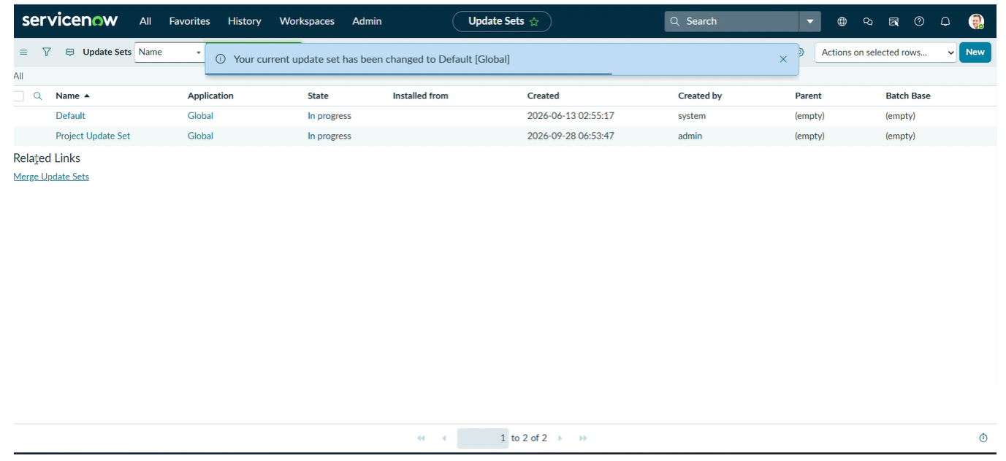

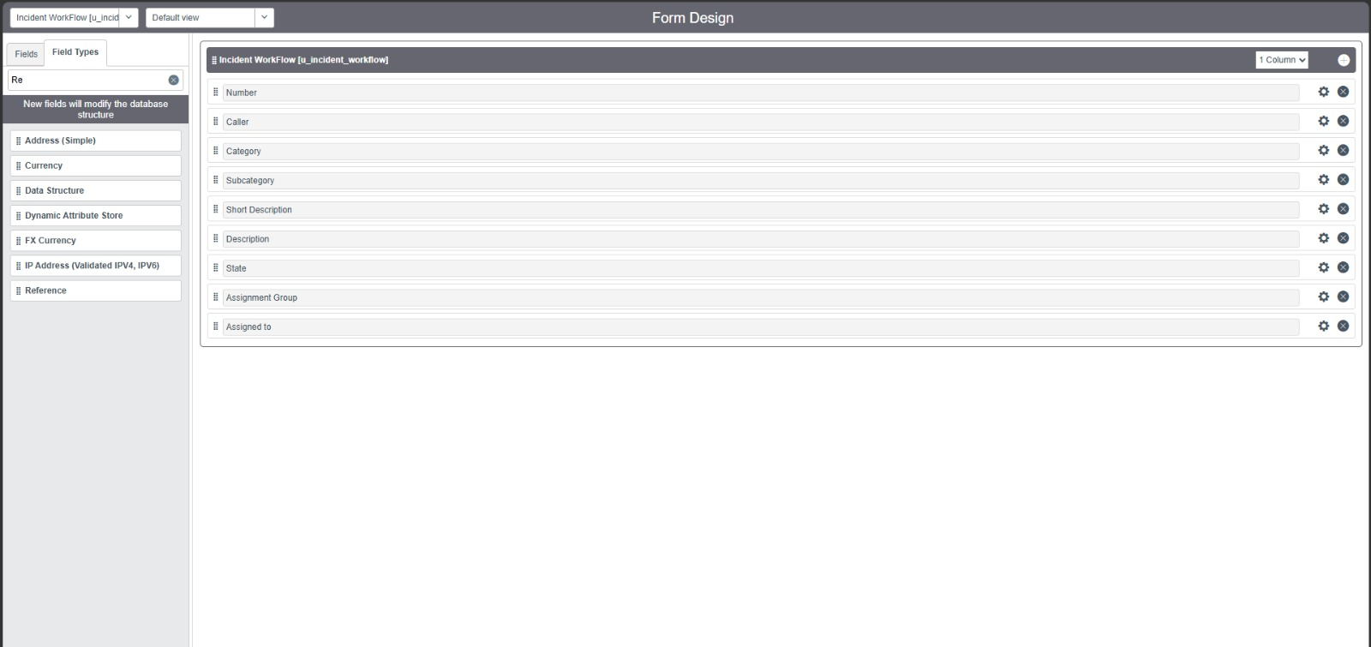

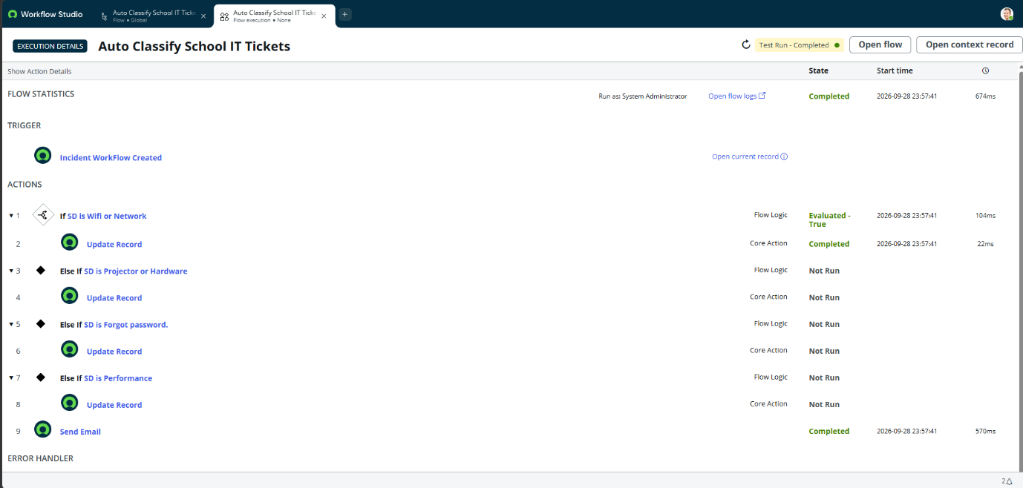

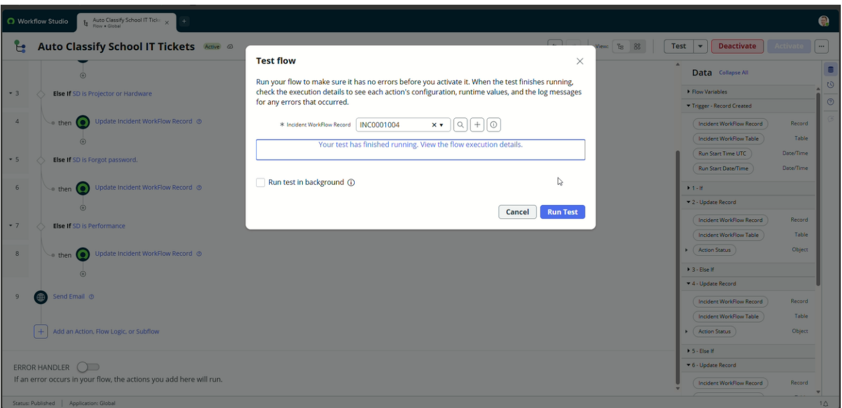

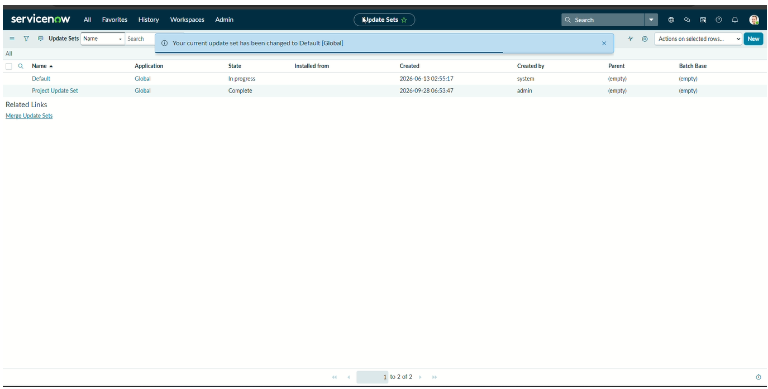

8. ADVANTAGES & DISADVANTAGES
Advantages
- Automatically classifies IT tickets.
- Reduces manual work for IT Helpdesk staff.
- Provides consistent Category and Subcategory assignment.
- Supports dependent Category–Subcategory choices.
- Sends automatic email notifications to callers.
- Stores ticket information in a structured format.
- Easy to maintain and extend with additional issue types.
Disadvantages
- Classification depends on the issue description and configured conditions.
- Incorrect or unclear descriptions may affect classification.
- Requires ServiceNow configuration and access.
- Changes to categories or classification rules require administrative updates.
- Email notification depends on the ServiceNow notification configuration.

9. CONCLUSION
The Automated School IT Ticket Classification and Notification System successfully addresses the problem of manual ticket classification in the school IT Helpdesk. The system automatically identifies common IT issues, assigns the appropriate Category and Subcategory, updates the ticket, and sends an email notification to the Caller.
The implemented solution improves consistency, reduces repetitive manual effort, and provides a structured approach for handling IT support requests.
10. FUTURE SCOPE
The system can be further enhanced by:
- Adding more IT issue categories and subcategories.
- Using AI or machine learning for advanced ticket classification.
- Supporting more complex issue descriptions.
- Adding dashboards for monitoring ticket statistics.
- Integrating automated assignment to specific IT support teams.
- Adding priority and urgency prediction.
- Providing SLA tracking and escalation.
- Integrating chatbot or virtual assistant support.
- Adding analytics to identify frequently occurring IT problems.
- Extending the system for mobile-based ticket management.

GITHUB LINK: https://github.com/bharsha525/Auto-Ticket-Classification-Using-Flow-Designer.git
DEMO LINK: https://drive.google.com/file/d/1XxFfOKuo-SFZmRXJAY4O9EQdhsOLSKSY/view?usp=sharing

